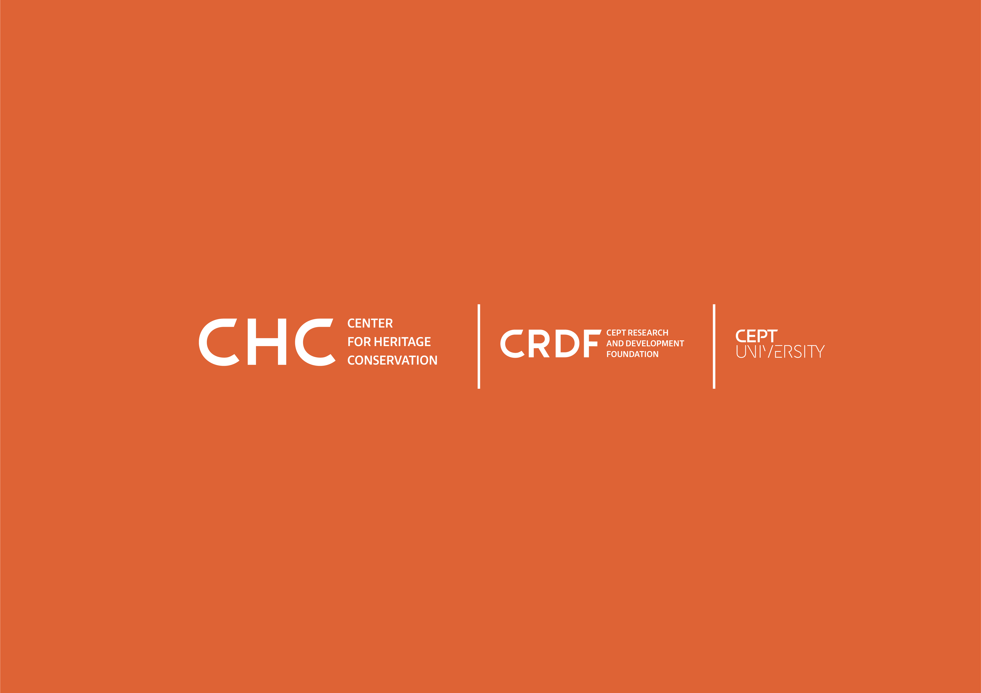

Documenting Cultural Heritage - From Analog to Digital: Online Certificate Course by CHC

Apply Now

Course Prerequisite: Participants must have a Bachelor's degree in any field allied to built environment studies. A resume/CV would be part of the registration process.

Course Fee: Rs 22,000 / $ 300 per student.

We have 25 seats available.

Alternatively, participants can download the form and email it with the required documents at chc@cept.ac.in. Add “Application for Online Course on Documenting Cultural Heritage” in the Subject line.

Selected candidates will be notified by email and will complete the registration process through the CRDF website.

First Name*

Last Name*

Date of Birth*
Month, day, year

Educational Qualification*

Mobile*

Email*

Address*

City*

Country*

Zip Code*

Statement of Purpose (250 words PDF format) Please attach a PDF with the form.*

Resume or CV (PDF format) Please attach a PDF with the form.*

Have you previously worked on documentation of a historic site? If yes, please write a short description about your experience.*

.

